May 2011
Sunday | Monday | Tuesday | Wednesday | Thursday | Friday | Saturday
1 | 2 | 3 | 4  ELA | 5 | 6 | 7  Lost your ESRT?  http://bit.ly/fdR5WR
8 | 9 | 10  The Prologue | 11  Math State Assessment | 12  Rocks and Minerals | 13  Open Review | 14  Need something to study?  http://bit.ly/eFxksQ
15 | 16  Age of the Earth | 17  Regents 1 Due  (will not be graded) | 18  Dynamic Planet  Review until 4:30  Pizza! | 19 | 20  Regents 2 Due | 21  Want to do another regents?  http://bit.ly/b1zJAy
22 | 23  Earth’s Dimensions | 24 | 25  Surface Processes  Review until 4:30  Pizza | 26  Regents 3 Due  ____________  Energy and Climate | 27  Last Day for all labs to be handed in! | 28
29 | 30 | 31  No Extra Help Today! |  | Please note, on days where pizza is served, students are expected to pay $2 per slice. This includes something to drink. | Open review is time for general help regarding the most current regents assigned. Please come with questions. | All highlighted tasks are due dates for assigned regents.
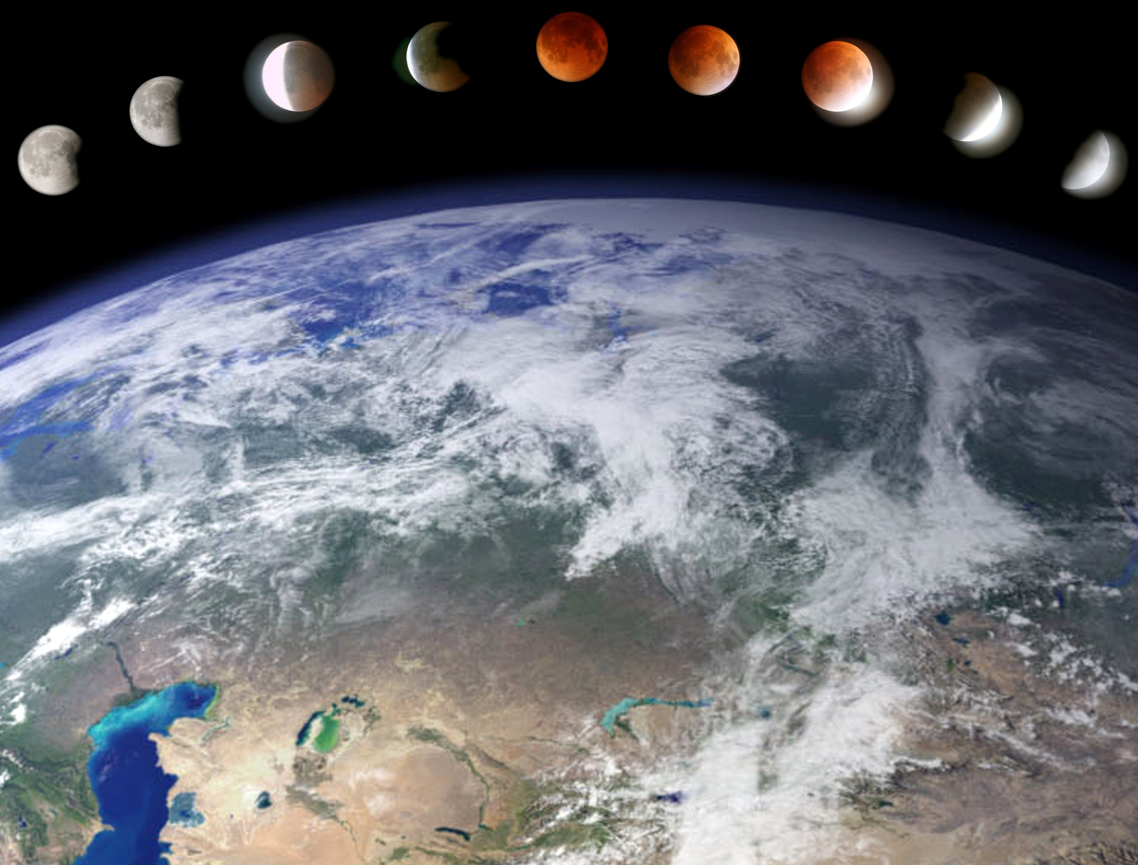
June 2011
Sunday | Monday | Tuesday | Wednesday | Thursday | Friday | Saturday
 |  |  | 1  Lab Practical  Lab Practical Review | 2  Regents 4 Due | 3  Open Review | 4
5 | 6  Open Review | 7  Weather | 8  Regents 5 Due  ________________  Open Review | 9  Sun’s Path & Astronomy  Earth Science Regents! | 10  Open Review | 11
12 | 13  Open Review | 14  Open Review | 15  Regents 6 Due  _______________  Open Review | 16  Math Regents  __________  Last minute review  4 – 6 in school library | 17 | 18
19 | 20 | 21 | 22 | 23  Last Day of School | 24 | 25
26 | 27 | 28 | 29 | 30

